construct PDA for following string aabb

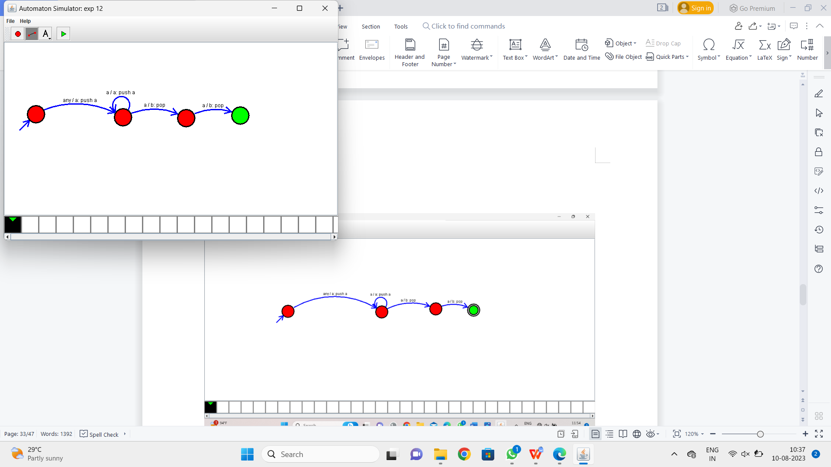

Result:-

From the above PDA diagram valid the string aabb